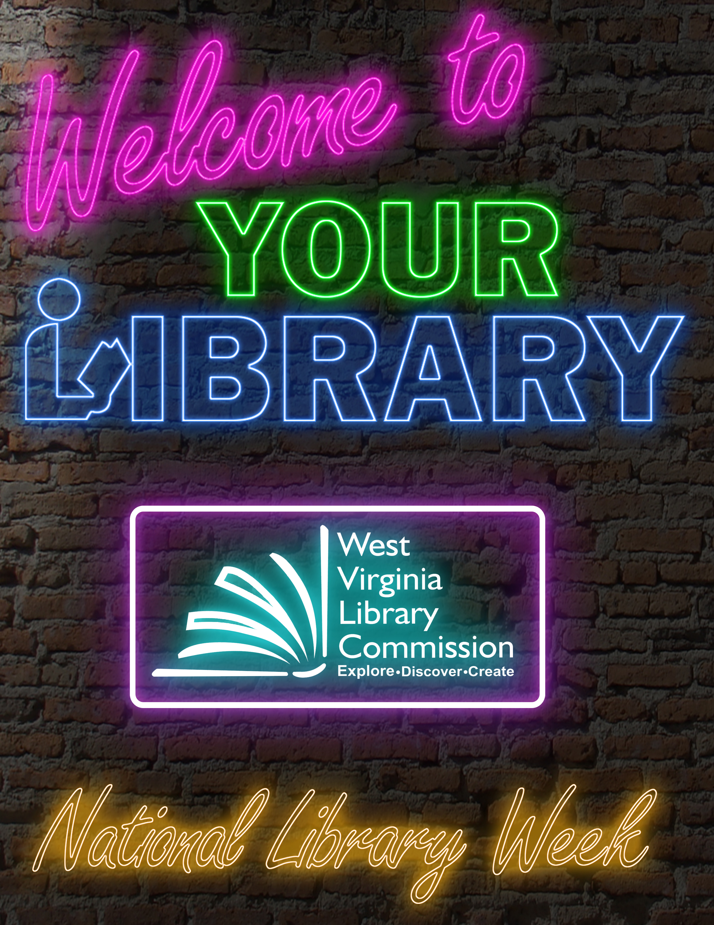

National Library Week 2021
Sample News Release
Edit copy as needed.
For Immediate Release:
[Date]
Contact: [name, title, phone number, email]
Welcome to Your Library, National Library Week set for April 4-10
(CITY, STATE) – This week, [Name of library] joins with other libraries across West Virginia and the nation to highlight the essential role libraries, librarians, and library workers play in transforming lives and strengthening communities.

National Library Week 2021’s theme, “Welcome to your library,” promotes the idea of libraries extending far beyond the four walls of a building and that everyone is encouraged to use the services. Whether people visit virtually or in-person, libraries are accessible and inclusive places that foster opportunities for all in the community.
During the challenge of the past year, libraries of all types have adapted in-person services, expanded online resources, created virtual programs, all while meeting critical needs of their patrons.

Libraries across West Virginia are making a difference in people’s lives by providing electronic learning resources for online homework help and wi-fi access to students and workers who may lack internet access at home. [Name of library] is supporting the community with virtual services such as [add your library’s programs].

This National Library Week, the public can show their appreciation and support for libraries by visiting their library’s website, following them on social media and using the hashtag #NationalLibraryWeek, #WVLibrariesWelcomeU.
First sponsored in 1958, National Library Week is a national observance sponsored by the American Library Association and libraries of all types across the country each April.
For more information, visit the library’s website at [URL].

###
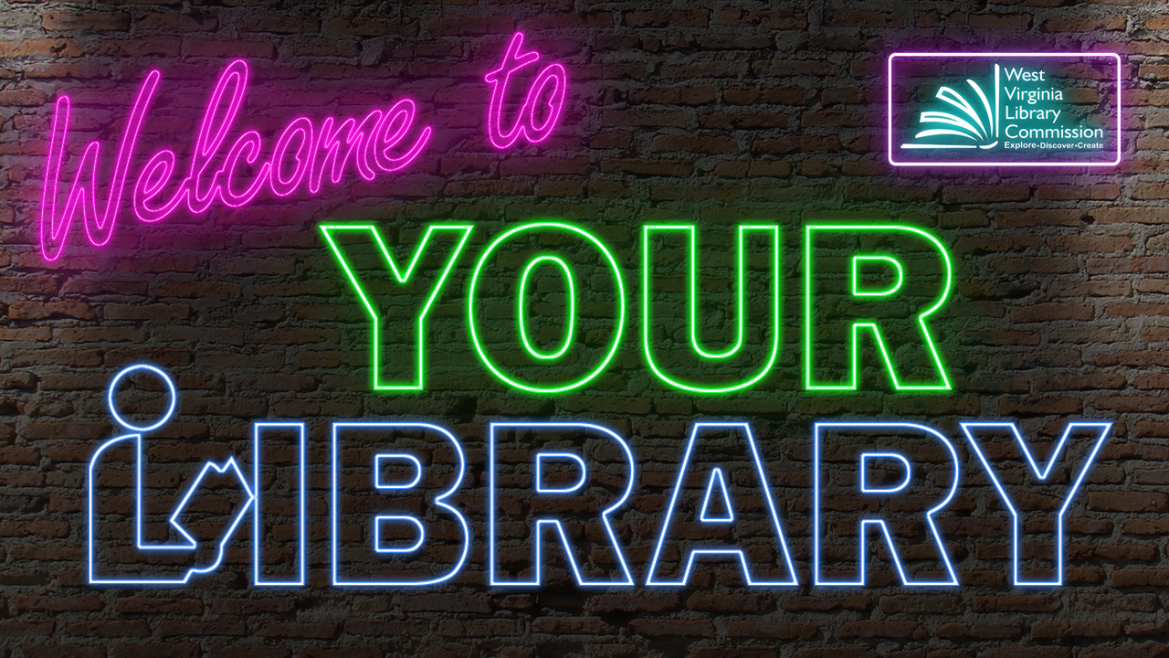
National Library Week 2021
Sample Social Media Posts

Happy #NationalLibraryWeek! Show your library some love by visiting them online or following them on social media: [link to your library’s website]. #WVLibraries #WVLibrariesWelcomeU
This #NationalLibraryWeek, check out something from your library’s digital collection like ebooks, movies, video games, and so much more! Visit [link to your library’s website]. #WVLibraries #WVLibrariesWelcomeU
The library has something for everyone! During #NationalLibraryWeek, visit your library online or in person to find everything from audiobooks and virtual story times to new technology and résumé help. #WVLibraries #WVLibrariesWelcomeU
Did you know you can access library resources and services from the comfort of your own home? This #NationalLibraryWeek, visit your library’s website to learn how! [link to your library’s website] #WVLibraries #WVLibrariesWelcomeU
There’s no better time than #NationalLibraryWeek to visit your library virtually or in person! Discover and explore new worlds through access to your library’s technology, multimedia content and educational programs. [link to your library’s website] #WVLibraries #WVLibrariesWelcomeU

Shout out the people who make libraries work. Happy National Library Workers Day
#WVLibraries #WVLibrariesWelcomeU #NationalLibraryWeek

